Fundraise

with Friends Kit
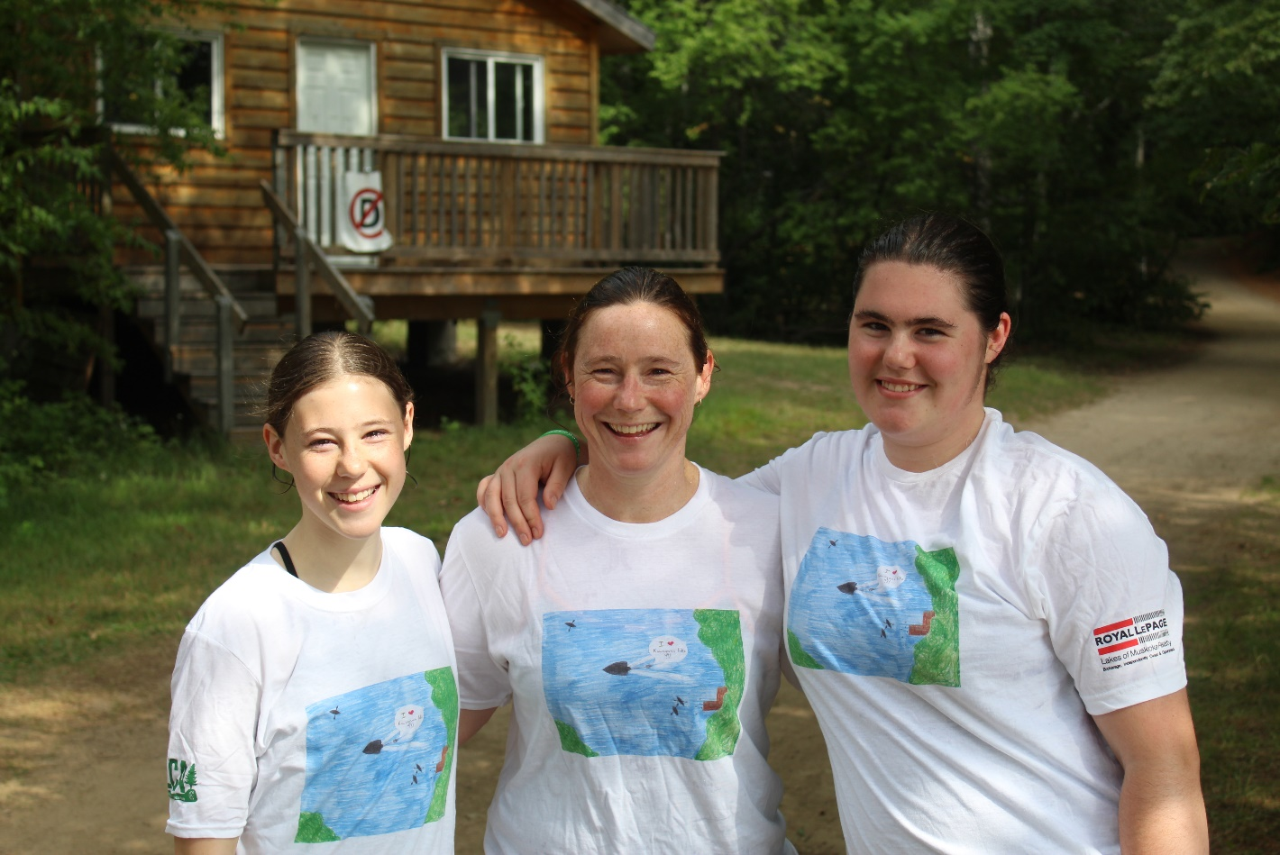

Fundraise with Friends & Empower Kids to Transform their Lives.
All kids have the potential to shine as leaders and achievers, but not all are given the building blocks needed to strengthen their skills and self-esteem. Since 1912, Moorelands Kids has been creating opportunities for kids from Ontario's poorest neighborhoods. Your fundraising efforts will help us bridge the opportunity gap for children affected by poverty and will give them the chance to achieve their potential.

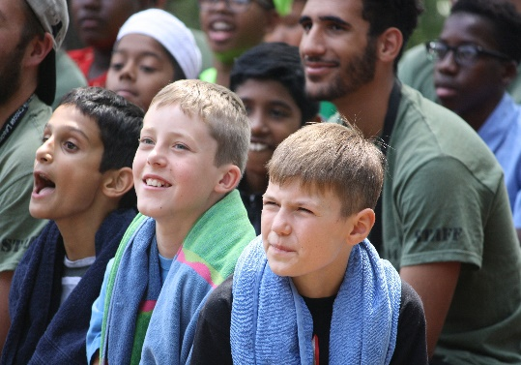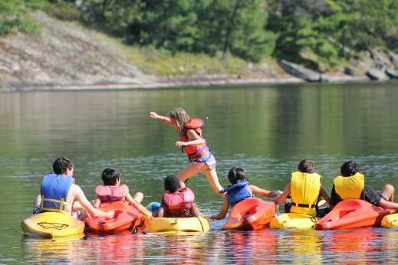
At Moorelands Kids, we aim to…
- Help kids develop leadership skills and positive character qualities with Moorelands Habits & Qualities.
- Enable kids to build self-awareness, self-esteem and confidence.
- Connect kids to their communities and positive role models.
- Show kids that the Habits & Qualities they practise in programs are transferable, preparing them to thrive in the world outside.

YOU can help us help kids by committing to raise funds to support our programs:
- Morelands Camp
- Moorelands Kids’ BLAST
- Moorelands Kids’ LED
- Moorelands Kids’ VITAL
- Moorelands Kids’ Holiday Sharing

You can choose to designate the funds you raise to a particular program, or you can leave it to us to apply the funds where they are most needed. Please consider fundraising with friends and helping us make a significant impact in the life of a child.

Fundraising Ideas
From concerts to golf tournaments, galas to ping-pong, or even social media campaigns, there are so many ways you can fundraise with friends.

Event Ideas
There is no limit to creativity when brainstorming ideas for a successful event. Here are just a few fundraising ideas to consider:

Auction
Arts and Crafts Sale/Show
Benefit Dinner
BBQ
Bingo Night
Birthday Campaign
Book Sale
Bowling Tournament
Casino Night
Cocktails for a Cause
Car Wash
Carnival/Festival
Concert/Play
Concession Stand
Craft Sale
Date Auction
Dinner Party
Donations in Lieu of Gifts
Face Painting
Facebook Campaign
Fashion Show
Fishing Derby
Flower Sale
Garden Sale
Garage Sale
Golf Tournament
Kickball/Softball Tournament
Lemonade Stand Loonie/Toonie Drives Monthly Giving Campaign
Pet Wash
Pledged Events
Poker Tournament
Proceeds from Sales
Raffle
Rummage Sale
Run/Walk/Ride
Scavenger Hunt
Social Media Campaign
Sporting Events
Tailgate Party
Ticketed Event
Traditional Gala Event
Wine Tasting
Work Challenges
Work Event

Matched Gifts: Why not double your fundraising efforts? Before you start coordinating your event, check to see if your employer has a “matching gift” program. Many employers sponsor programs to match any charitable contributions made by their employees. They may also offer release time for volunteer efforts.

Tips for Fundraising Success:

Step 1: Choose your event idea.
Step 2: Pick a date/time of the event.
Step 3: Create a budget.
Step 4: Create a plan and set deadlines.
Step 5: Promote your event. See our FAQs (page 7) to learn how Moorelands Kids can help you.

Fundraising Guidelines
1. Moorelands Kids encourages fundraising events that are compatible with our mission, vision and values. Prior approval is appreciated, and given based on the type, theme and financial viability of the event.
2. To conduct a fundraising event, please contact Colette Halferty, Director of Development and Communications at chalferty@moorelands.ca or by phone 416-466-9987 Ext. 307, at least 15 days prior to your event.
3. Any organization/group wishing to use the Moorelands Kids name or logo on any materials, including advertising, must receive approval from Moorelands Kids. Please contact Colette Halferty at chalferty@moorelands.ca for all inquiries about communications materials.
4. All promotional materials must state that your event is “in support of Moorelands Kids” to acknowledges that this is not an official Moorelands Kids event.
5. Taking commission, for any purpose, on funds raised as part of an event is prohibited.
6. The event organizer is responsible for meeting all municipal/provincial or federal standards and fulfilling all legal authorization(s), permit(s), license(s), precaution(s) and/or general liability insurance required to organize the event. Moorelands Kids must not be party to any liability coverage without prior knowledge and/or approval. Moorelands Kids accepts no legal responsibility and cannot be held liable for any risk, injury or otherwise.
7. Moorelands Kids agrees to provide the sponsoring organization/group with appropriate recognition as set forth in our Donor Recognition Policy.

8. The event organizer will be responsible for all costs related to the event and will submit the final donation to Moorelands Kids within 30 days of the event. Event expenses are to be deducted before sending proceeds to Moorelands Kids.
9. When tax receipts are requested, the event organizer is responsible for collecting the names, addresses and contact information of all donors, and is required to mail the appropriate materials to Moorelands Kids within 30 days of the event. Tax receipts require a minimum donation of $15. Refer to Tax Receipting (page 5) for more details.
10. Involvement of Moorelands Kids staff and volunteers will be at our discretion and will be based on availability, location and the nature of the event.

11. Moorelands Kids will not be responsible for any damage or accidents to any persons or property; we will not assume any legal or financial liability caused before, during or after the event. Depending on the nature of the event, the organizer may be required to submit proof of general liability insurance in the amount of $2,000,000 to cover any damage or accidents arising out of the third-party event. In acquiring insurance for an event, it is the responsibility of the organizer to apply and obtain such documents in the name of the individual, organization or business coordinating the event.

12. Moorelands Kids will not be responsible for mailing materials to attendees/participants or volunteers, other than the mailing of applicable tax receipts.

15. The event organizer must send a complete accounting of all income and expenses associated with the event to Moorelands Kids. By publicly naming Moorelands Kids as the beneficiary of your initiative, you are required to donate the net proceeds to us within 30 days of the event completion.

Please send a cheque made payable to:
MOORELANDS KIDS
601-251 Consumers Road
Toronto, ON M2J 4R3
Attn: Colette Halferty, Director of Development and Communications

Tax Receipting

What will Moorelands Kids provide a tax receipt for?
Moorelands Kids adheres to the Canada Revenue Agency (CRA) Income Tax Act when issuing charitable tax receipts. To learn more about charitable tax receipts, please visit http://www.cra-arc.gc.ca. Issuing inappropriate charitable tax receipts can put our charitable status in jeopardy.

Under CRA guidelines, a “gift” is a:
Voluntary transfer of property with a conscious desire to make a gift (as distinguished from giving something for nothing by mistake or under pressure).
- Voluntary – given of free will (not compelled, not court ordered, etc.)
- Transfer – from donor to charity/qualified done (complete transfer)
- Property – cash or gifts in kind (not services)

Moorelands Kids will provide a tax receipt for the following:
- Direct personal or corporate donations of $15 or over (unless otherwise requested by the donor)
- Gift-in-kind donations where fair market value is easily determined
  - Tickets (sporting events, theatre, ballet, etc.) where the value is either noted on the ticket or a payment receipt is provided.
  - Air miles or payment of flights (again, proof of payment must be provided)
  - Gifts of artwork provided the artwork has been appraised by a third-party appraiser – appraisal must be included with the donation
  - Gifts of shares
  - Bequests
  - Life insurance premiums
  - Monthly donations (donor will receive one cumulative income tax receipt at the end of the calendar year)

Moorelands Kids cannot provide a tax receipt for the following:
- Gifts of promises or pledges (for example, gift certificates donated by the issuer, hotel accommodation)
- Payment of basic fee for an event
- Gifts where the value or benefit of the donation cannot be determined
- Lottery or raffle tickets
- Donations of services (time, skills, or efforts) or loans of property, use of a timeshare or lease of premises
  - Donations of services will only be receipted when a ‘cheque exchange’ takes place. This means that the party who donated a service would invoice Moorelands Kids for the cost of the services. Moorelands Kids would then issue a cheque for the services. If the service provider should choose to donate these funds back to Moorelands Kids, then Moorelands Kids can issue a tax receipt for the amount of the donation.
  - Two distinct transactions must take place:
    - A person provides a service to Moorelands Kids and is paid for that service, and
    - That same person makes a voluntary gift of property to Moorelands Kids
- Funds or gift in kind is from another qualified donor (gifts from other registered charities, or non-profit organizations)
- Name of true donor(s) cannot be determined (for example, bottle collection from several parties, donation bins, etc.) – one person cannot benefit from gifts made by multiple donors
- Gift is directed to a specific person or family unless Moorelands Kids has already decided that person or family is the recipient of the charitable program and Moorelands Kids has full discretion to reallocate funds and the person or family is arms-length from the donor
- Rent-free space
  - One of the criteria for a gift is that there be a voluntary transfer of property
  - With rent free space or accommodation, no property is being transferred – instead, use of the building is being provided. Since no property is transferred, no “gift” is made and a tax receipt for the value of the loan of property cannot be issued
- Court ordered donations (donations made as a condition of parole)
- Gifts intended for another organization
- Donations of items for auction (unless pre- approved by Moorelands Kids)
- Sponsorships

Frequently Asked Questions

Will Moorelands Kids help organize events?
This fundraising toolkit will help get you started on planning your fundraiser. Although the majority of fundraising event coordination lies with the fundraiser, we may be able to assist with guidance and resources, please contact us if you have any questions about what we can provide.

Is Moorelands Kids able to support any third-party event expenses?
It is the responsibility of the event organizers to create a budget and manage it accordingly for all expenses.

Can Moorelands Kids provide volunteers for an event?
It is the responsibility of the event organizers to recruit, train and manage all volunteers.

Can Moorelands Kids provide a website page for my event?
Moorelands Kids can host a web page for your event on our website, www.moorelands.ca. This page can be used to gather donations from your fundraiser. If you are interested, please contact us.

Will Moorelands Kids help promote my event?
If you would like promotional support for your event, Moorelands Kids is happy to include details in our online communications (emails, social media, etc.) We can also post your fundraiser on our Events web page. Any additional promotion is the responsibility of the event organizers. All publicity for the proposed event must be approved by Moorelands Kids prior to being printed and/or released, including web content, press releases and printed materials. Please forward all content for approval at least 10 days in advance of release to Colette Halferty at chalferty@moorelands.ca. For questions about how our communications team can support your fundraiser, send us an email or call us at 416-466-9987 ext. 307.

How do I send the proceeds of my event to Moorelands Kids?
Funds raised by an event should be made payable and turned into Moorelands Kids no later than 30 days after the event, unless they are cash funds which must be turned into the agency no later than 3 days after the event. It is preferred that all funds raised are deposited into one account and a cumulative cheque is written to Moorelands Kids. Cash must be in a sealed envelope, counted, with a count sheet detailing the funds included. Please make cheques payable to:

MOORELANDS KIDS
601-251 Consumers Road
Toronto, ON M2J 4R3
Attn: Colette Halferty, Director of Development and Communications

Can I use the Moorelands Kids logo and how do I get it?
Please contact Colette Halferty at chalferty@moorelands.ca for inquiries about logo use.

Can Moorelands Kids provide print and promotional/display materials?
Moorelands Kids can provide print materials about our programs and services. We may also be able to provide banners, subject to availability. Please send all requests for Moorelands Kids materials at least 10 days prior to your event by email to Colette Halferty at chalferty@moorelands.ca.

If I have a silent auction at my event, how do I get items for the auction?
It is the responsibility of the event organizer to solicit for prizes to support your event. We can provide a letter from Moorelands Kids authenticating your event to support your solicitation efforts. If you require an authentication letter from Moorelands Kids, please email your request to Colette Halferty (chalferty@moorelands.ca) or call us at 416-466-9987 ext. 307.

There are many ways to build your live and/or silent auction:
- Donated Items - Create an ask letter to send to various companies requesting items for your auction that is in support of Moorelands Kids
- Auction Houses – There are companies that build inventories of items for silent/live auctions, such as sports memorabilia, music collectables, etc. You are typically only required to pay for items that sell, and can return any items that don’t. Reminder: Set minimum bids for these items to ensure that you are selling them for more than you are paying for them.
- Purchased – You always have the option of purchasing items for the auction, however, the cost of these items are the responsibility of the organizers.

